First I would like to thank Elonka and of curse Mr. Sanborn for allowing me the opportunity to meet with some of the Kryptos community. Fortunately I sat two seats down from Jim Sanborn so I was able to ask some questions off the record, although I decided not to harass him too much and to let him enjoy his dinner.
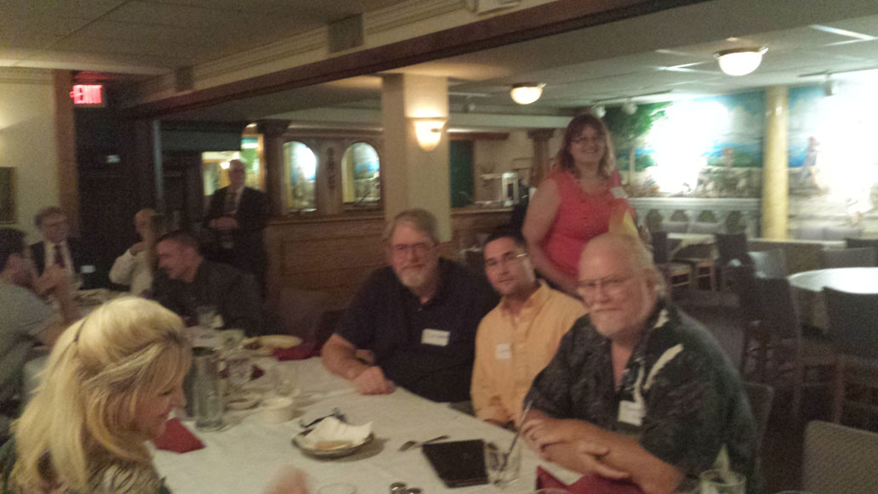

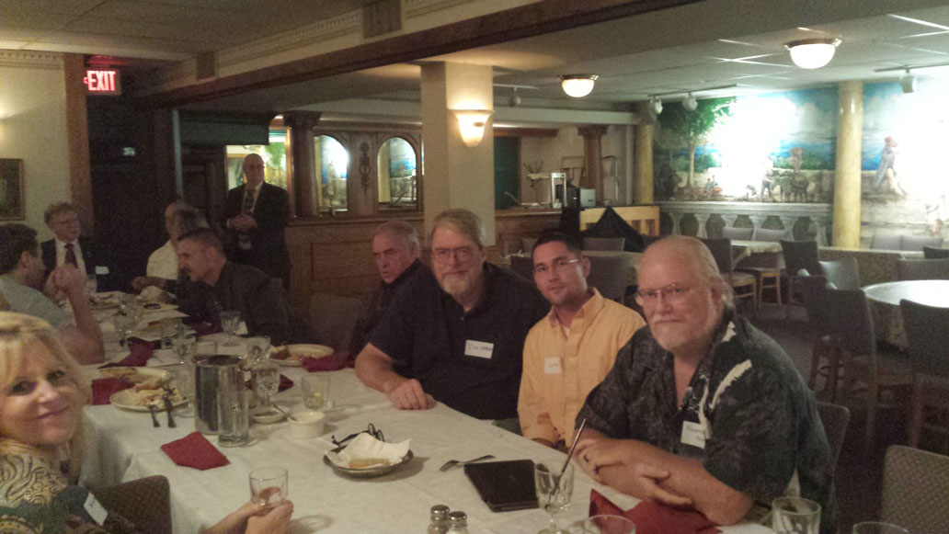
While the below image was displayed on the projector, Mr. Sanborn spoke to a gentleman across the table and stated that he was surprised that no one has caught on to some clues within this document.
Me: Like that there are no misspellings?
Mr. Sanborn: Yes, that is what we are talking about!
There may be more…..
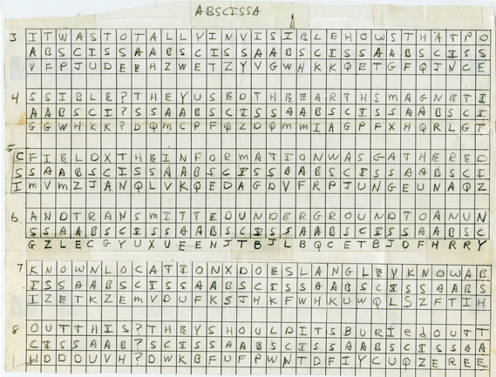

Me: The Kryptos sculpture tableau, what does it represent?
Mr. Sanborn: The petrified tree was a symbol of a forest that was cut down to build the CIA headquarters; it was quite controversial at that time. There was also talk about how there were tree frogs in the little cracks of the fossilized tree when he picked it up and that he could only travel 55MPH from Arizona to Virginia in his crappy rental truck used to transport the tree.
Layout - The stones and main sculpture form lines that cut through the CIA building, as if to expose it. Someone else mentioned that there may be some significant historical lines, but I did not register because it did not come from Mr. Sanborn’s mouth.
Granit slabs – Represent the history/layers of encryption at the CIA much like a book, the layers can be peeled back.
I didn’t get to ask about the stones in front of the main sculpture, the whirl pool, or if the sculpture represented a tape recording, a radio transmission, or a scroll.

Unknown: Is BERLIN a misspelling, a single word, or a conjunction of two words such as rememBER LINcoln or septemBER LINt?
You could tell that Mr. Sanborn was hiding a smile and was thinking of how to answer the question and may have been interpreted as him stonewalling the question. In the end he softly spoke “ It’s the city..it’s the city.” Not sure if anyone heard him, there was quite a squabble over how to ask the question and refining what the speaker meant.

Me: Is BERLIN an encryption or decryption of NYPVTT?
Everyone: OMG everyone knows this, blah blah blah. I think the two NSA guys called me stupid. (joke).
Mr. Sanborn: It’s a decryption.

